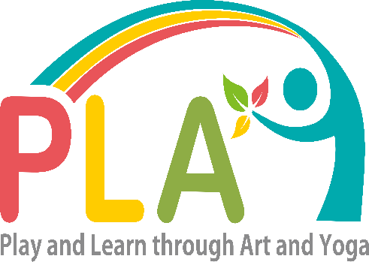
SCHOOL INFORMATION

Name of School____________________
Grade levels requested for program ___________________________
Average number of students per grade___________________________
Please circle the type of class you are requesting:
- Art- 30 min
- Yoga- 30 min
- Art and Yoga - 45 min combined class, 20 minutes of yoga and 20 minutes of art
Number of classes school is requesting_____________
Date and time of classes _________________________________
There will be 2 teachers per class and possibly an intern or volunteer. We ask that the teachers please stay in the classroom during activities and communicate with PLAY teachers any needs or concerns with their students.
We look forward to seeing you soon!
The PLAY Team
Information and Benefits on Mindfulness Through the Practice of Art and Yoga
- Enhances Concentration
- Mind relaxation
- Self-awareness
- Increases body balance and flexibility
- Boosts confidence
- Improves movement
- Improves overall well being
- Enhances social and emotional learning skills

